Course Methods test 3 Year 12

Student name: ________________ Teacher name: ________________

Task type: Response

Time allowed for this task: ___40________ mins

Number of questions: ____8_______

Materials required: Calculator with CAS capability (to be provided by the student)

Standard items: Pens (blue/black preferred), pencils (including coloured), sharpener, correction fluid/tape, eraser, ruler, highlighters

Special items: Drawing instruments, templates, notes on one unfolded sheet of
A4 paper, and up to three calculators approved for use in the WACE examinations

Marks available: ___46___ marks

Task weighting: _10___%

Formula sheet provided: Yes

Note: All part questions worth more than 2 marks require working to obtain full marks.

Q1 (3 marks)
The expected value of the discrete probability distribution given below is 2.8. Determine the values of and hence determine Var(), the variance of .

 | 1 | 2 | 3 | 4 | 5
P() | 0.1 |  | 0.2 |  | 0.1

Solution
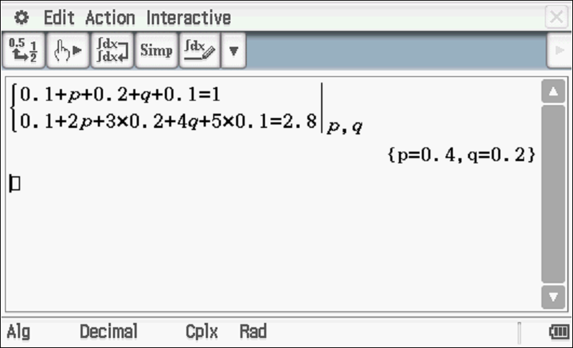

Specific behaviours
sets up one equation with p&q
sets up two equations with p&q
solves for both p&q
(Note: max 2 marks if no working shown)

Q2 (9 marks)
A students wishes to play a gambling game on mufti day involving throwing two regular fair dice, each numbered 1 to 6. To play the game the student must pay $2 for each throw of two dice. If they score a double i.e two 1s, two 2s etc they win $6. If they throw a total of 7 they win $11 and anything else they receive nothing.
Let $ equal the profit a player receives on a single play.
- Describe the random variable . (1 mark)

Solution
Discrete random variable

Specific behaviours
states discrete

- Complete the following table for . (3 marks)

Solution
 | $9 | $4 | -$2
P()

Specific behaviours
correct values for x
at least 1 probs correct
all probs correct

- Determine the expected profit by a player on a single game. (3 marks)

Solution
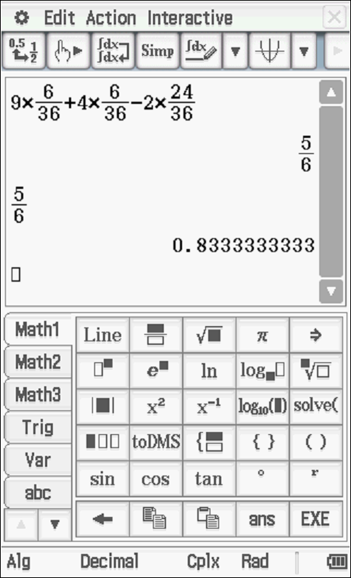

Specific behaviours
multiplies x by prob
shows sum of products
states expected profit, approx. or exact (no need for units)
(Note two marks for answer only)

- Determine the standard deviation of . (3 marks)

Solution
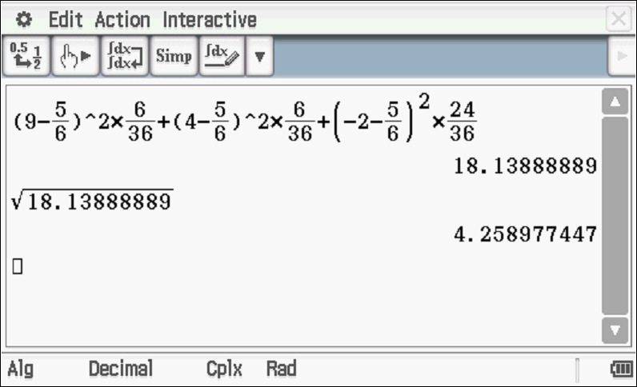

Specific behaviours
shows calculation
determines variance
states standard deviation
Note: Answer only two marks- third mark refers to shown working

Q3 (7 marks)
A factory produces toy cars. The probability that any toy car being defective is 0.15. If 20 toy cars are selected at random, let equal the number of defective cars out of 20.
- Describe the distribution . ( 2 marks)

Solution
Specific behaviours
states Binomial
states n & p

- Determine that probability that exactly 4 cars will be defective. (2 marks)

Solution
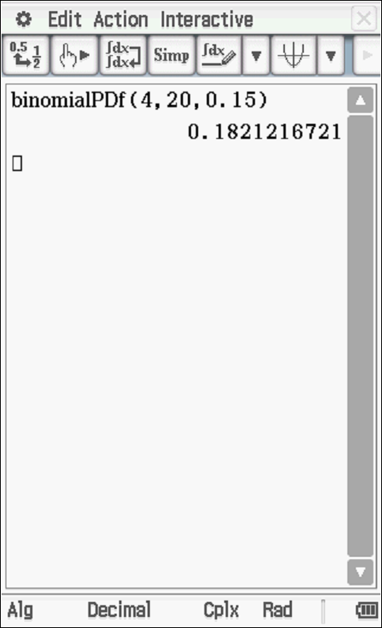

Specific behaviours
uses correct parameters
states prob

- Determine the probability that at least 4 cars will be defective given that we know at least 2 cars are defective. (3 marks)

Solution
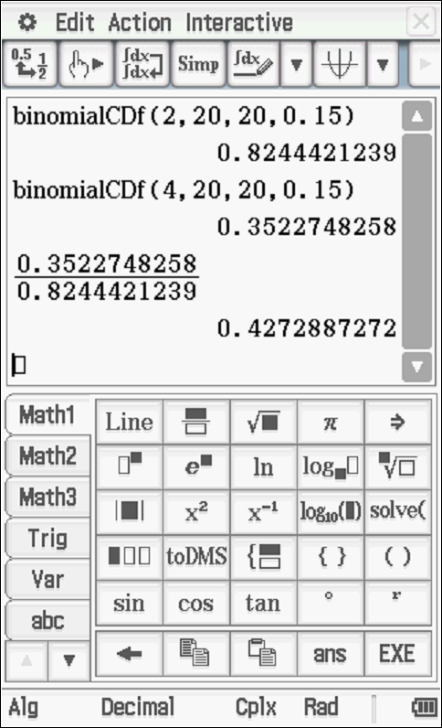

Specific behaviours
uses conditional prob reasoning
shows numerator and denominator values
states prob

Q4 (4 marks)
Sound loudness, dB, is measured by comparing the intensity of the sound, , with the intensity of a sound that is just detectable by the human ear, .

.
- If the noise level in a room was 65 dB, express the intensity of sound in this room in terms of .. ( 1 mark)
Solution
Specific behaviours
states expression

- How many times is the intensity of a 105 dB noise level that of the intensity of a 35 dB noise level? (3 marks)

Solution
Specific behaviours
uses index form
shows the powers of 10 for both levels
states simplified ratio

Q5 (5 marks)
Below is a graph of where is a positive constant.

- Sketch on the axes above labelling major features. (2 marks)
Solution
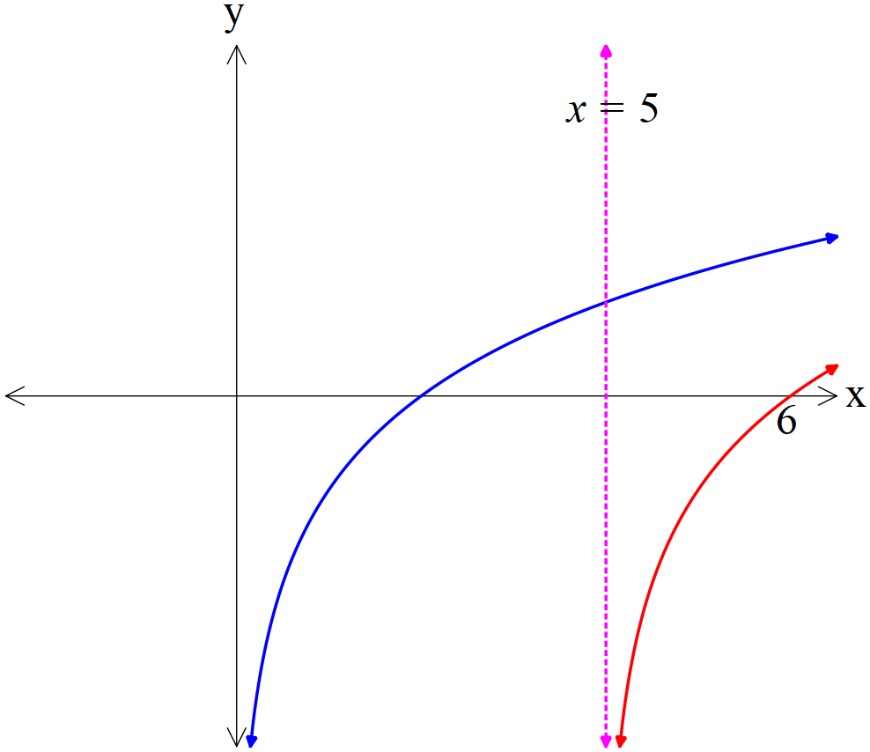

(Not drawn to scale)
Specific behaviours
labels new x intercept at x=6 AND appears to translate to the right
shows a dotted line as asymptote and labels equation

- Determine the values of given that contains points and has a vertical asymptote at . ( 3 marks)

Solution
Specific behaviours
states value of
sets up equations containing
states exact values of

Q6 (6 marks)

- Determine . (simplify) (3 marks)

Solution
Specific behaviours
shows use of product rule
at least one product correct
states simplified derivative

- Using your result in a) above and NOT using your classpad determine
. Show all working. (3 marks)

Solution
Specific behaviours
uses linearity (integrates exp in (a) above)
integrates squared term and adds a constant
obtains exp for required integral (no need to factorise)
(zero marks for answer only- from classpad)

Q7 (6 marks)
Consider the continuous random variable and its probability density function shown below.

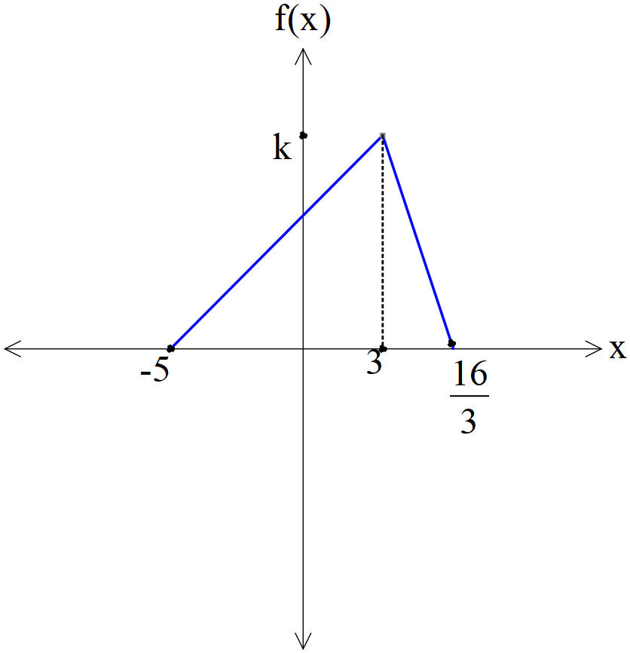 | - Determine the exact value of . (2 marks)  Solution  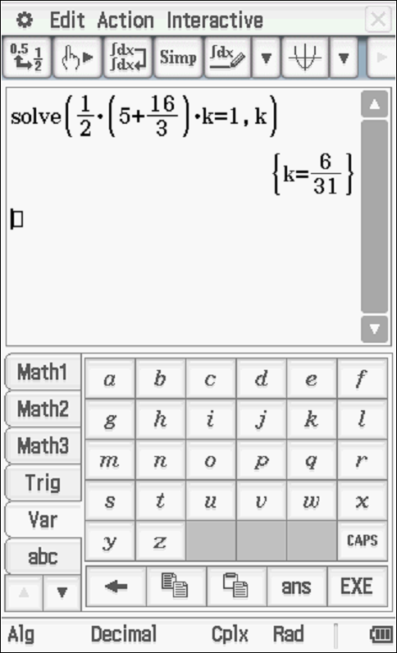  Specific behaviours  uses total area of one  solves for exact value of k  - Determine Prob  (4 marks)

Solution
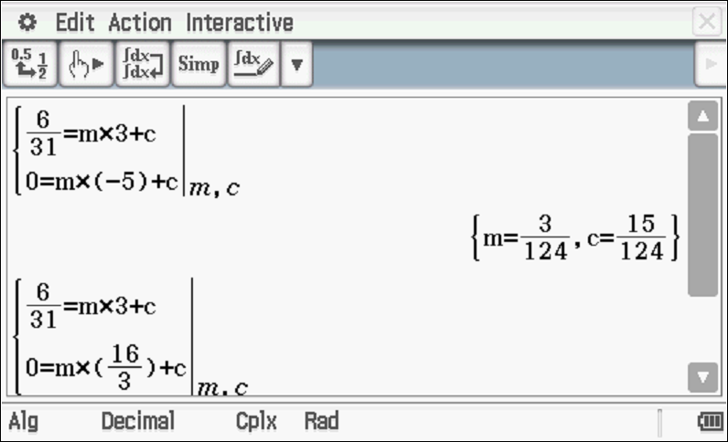
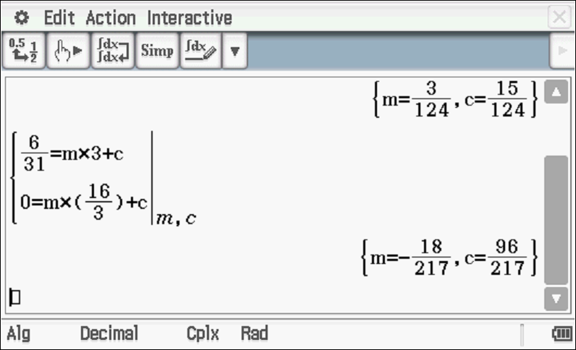
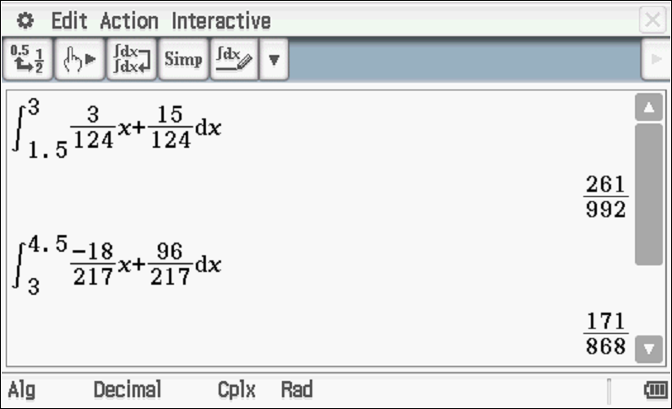
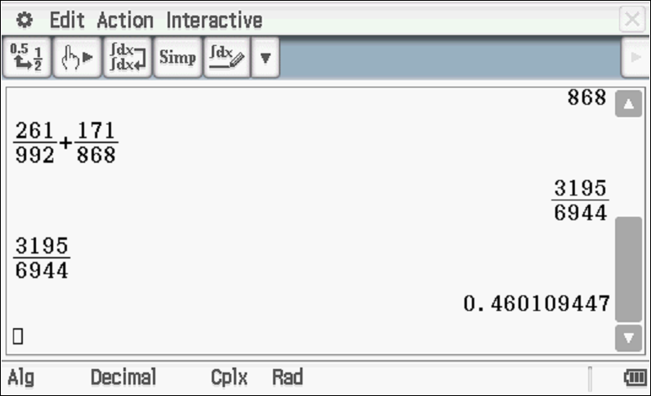
Prob = 0.4601
Specific behaviours
determines equation of one side
determines equations of both sides
states integrals with correct limits for total area
states approx. area to 4 decimal places (accept exact)

Q8 (5 marks)
Consider a continuous random variable, , that has the following probability density function.

with being constants.

- Determine the cumulative distribution function, , in terms of .
(2 marks)

Solution
Specific behaviours
integrates with correct limits (no need to change variables)
states cumulative function

- Given that solve for approximate values of to two decimal places.
(3 marks)

Solution
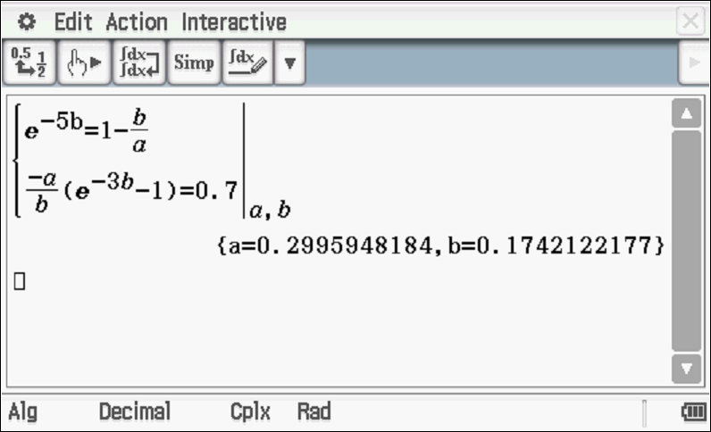

a=0.30 & b=0.17
Specific behaviours
sets up equation using total prob of one with x=5
sets up second equation at x=3
solves for a & b to two decimal places (must round)

